1.

If A = {1, 3, 5, 7, 9, 11, 13, 15} and B = {3, 6, 9, 12, 15}, find n(A∩B).
A.
3
B.
5
C.
10
D.
15

2.

If P = {4, 8, 12, 16, 20}, Q = {16, 4, 12, k, 20} and P = Q, find the value of k.
A.
20
B.
16
C.
8
D.
4

3.

Express 7352.4658 correct to three significant figures.
A.
7352465.8
B.
7352.47
C.
7350
D.
735

4.

Find the difference between the values of (2d)² and 2d², when d = 3.
A.
0
B.
18
C.
24
D.
54

5.

Find the image of p(-3, 5) when rotated through 360º about the origin.
A.
(5, -3)
B.
(-3, -5)
C.
(-3, 5)
D.
(-5, -3)

6.

The image of P(10, -3) when translated by the vector r is P’ (4, 5). Find r.
A.
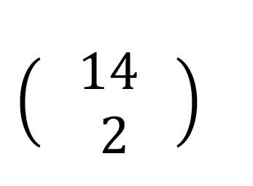
B.
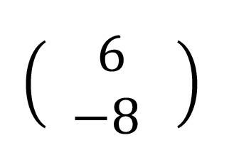
C.
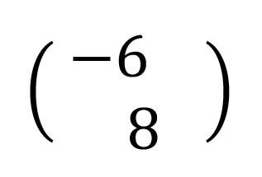
D.
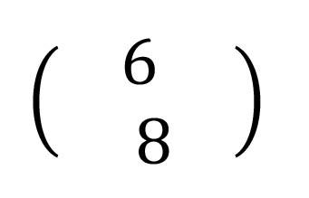

7.

Find the next two terms of the sequence: 2, 5, 10, 17, ....., ......
A.
24, 35
B.
26, 35
C.
26, 37
D.
27, 38

8.

Express 134.78 correct to the nearest tenth
A.
130.0
B.
134.7
C.
134.8
D.
135.0

9.

Kofi and Ama shared an amount of GH₵ 3,000.00 in the ratio 2:3. Find the amount received by Kofi.
A.
GH₵ 1,000.00
B.
GH₵ 1,200.00
C.
GH₵ 1,500.00
D.
GH₵ 1,800.00

10.

If 2x – 1 = 5, find the value of x.
A.
3
B.
4
C.
5
D.
6

11.

Solve: (1-x)÷3 < 4.
A.
x < -11
B.
x > -11
C.
x < 11
D.
x >11

12.

The area of a rectangle is 18 cm². If one of its sides is 2cm long, find its perimeter.
A.
18 cm
B.
20 cm
C.
22 cm
D.
36 cm

13.

A bag contains 5 red and 7 black balls of the same size. What is the probability of picking a black ball?
A.
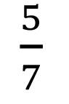
B.
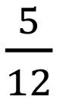
C.
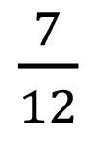
D.
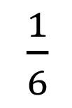

14.

On a map, 1⁄3 cm represents 5km. If two towns A and B are 18 cm apart on the map, what is the actual distance between them?
A.
27 km
B.
30 km
C.
240 km
D.
270 km

15.

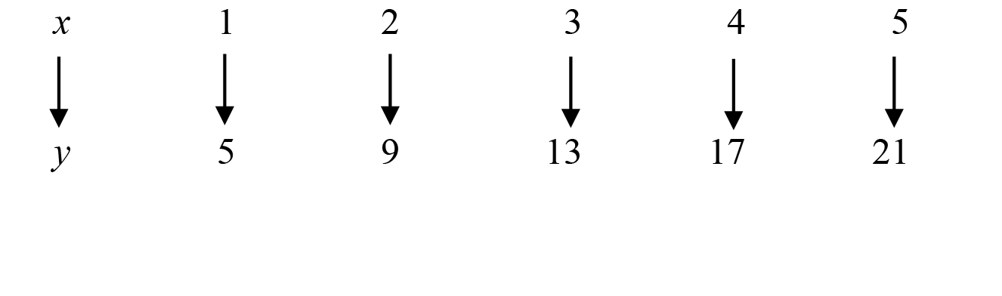
What is the rule for the above mapping?
A.
y = x + 4
B.
y = 3x + 2
C.
y = 4x + 1
D.
y = 5x + 1

16.

Find x when y = 37 for the above mapping
A.
6
B.
7
C.
8
D.
9

17.

Esi bought a television set for GH₵ 1,500.00. If she sold it at a profit of 20%, find the selling price.
A.
GH₵ 1,200.00
B.
GH₵ 1,500.00
C.
GH₵ 1,750.00
D.
GH₵ 1,800.00

18.

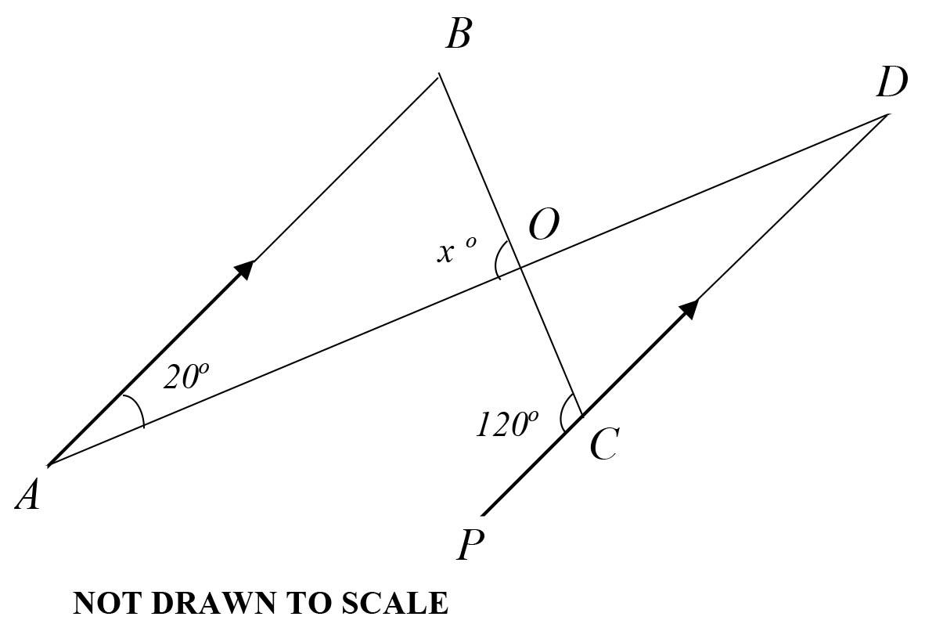
In the diagram, line AB is parallel to line PD. Find the value of x.
A.
20º
B.
80º
C.
100º
D.
120º

19.

Make h the subject of the relation V = πr²h.
A.
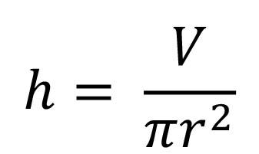
B.
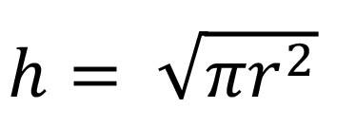
C.
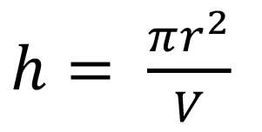
D.
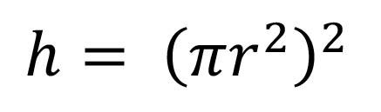

20.

Find the simple interest on GH₵ 600.00 which was saved for 8 months at 5% per annum.
A.
GH₵ 20.00
B.
GH₵ 40.00
C.
GH₵ 45.00
D.
GH₵ 240.00

21.

Priscila's age i k years while Mary's age is b years. If Mary is 15 years older than Priscila, Which of the following statements is correct?
A.
2k + b = 15
B.
b - k = 15
C.
k - b = 15
D.
2b + k = 15

22.

What is the Highest Common Factor (HCF) of 24, 32 and 64?
A.
4
B.
6
C.
8
D.
16

23.

Factorize: 3ax + 6a - x - 2
A.
(3a+1)(x+2)
B.
(3a+1)(x-2)
C.
3a(x-2)
D.
(3a-1)(x+2)

24.

A car covered a distance of 150 km at a speed of 18 km/h. Find the time taken.
A.
7 hours 33 minutes
B.
7 hours 53 minutes
C.
8 hours 13 minutes
D.
8 hours 20 minutes

25.

Simplify

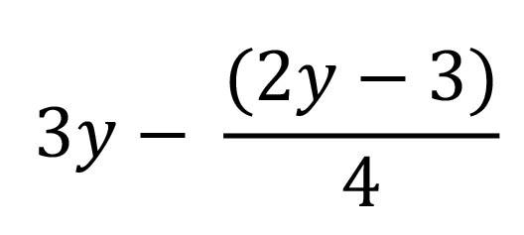
A.
10y + 3
B.
10y - 3
C.
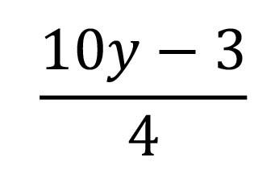
D.
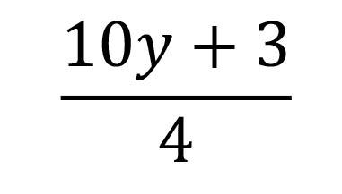

26.

Divide 0.5445 by 0.09.
A.
5.05
B.
6.05
C.
6.50
D.
60.50

27.

If the median of the numbers 9,10,12,x, 20 and 25 is 14, find the value of x.
A.
14
B.
16
C.
18
D.
22

28.

Expand (7r - 5)(3r+4).
A.
21r² + 13r - 20
B.
21r² - 13r - 20
C.
21r² - 43r - 20
D.
21r² + 43r - 20

29.

Find the gradient of the line that joins the points A(-3,5) and B(7,-2).
A.
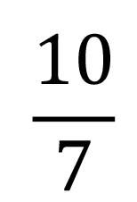
B.
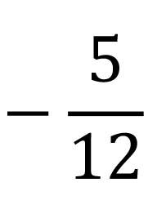
C.
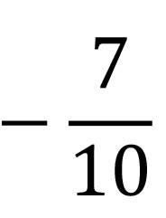
D.
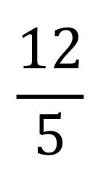

30.

The area of a trapezium is 36 cm². If the parallel sides are 10.5 cm and 9.5 cm, calculate the distance between the two parallel sides.
A.
1.0 cm
B.
1.8 cm
C.
3.2 cm
D.
3.6 cm

31.

If the average of 5,6,7 and x is 8, find the value of x
A.
12
B.
14
C.
16
D.
24

32.

An amount of GH₵ 375,000.00 was needed to build a clinic for a community of twelve towns. Each community contributed GH₵ 25,000.00. If the District Assembly also contributed GH₵ 30,500.00, how much more is needed to build the clinic?
A.
GH₵ 44,500.00
B.
GH₵ 45,500.00
C.
GH₵ 35,500.00
D.
GH₵ 75,000.00

33.

Which property of arithmetic is shown in the equation (6 + x) + 5 = 6 + (x + 5)
A.
Commutative
B.
Associative
C.
Closure
D.
Distributive

34.

A trader bought 100 tubers of yam for GH₵ n each. All the yams were sold at GH₵ m each. Find the profit.
A.
GH₵ 100(m - n)
B.
GH₵ 100(m + n)
C.
GH₵ 100(n - m)
D.
GH₵ 100( nm )

35.

A box can take 12 pencils. If 156 pencils are packed into such boxes, how many boxes will be fully packed?
A.
10
B.
11
C.
12
D.
13

36.

Given that x = 4, y = 7, evaluate 2xy + 3(x+y)
A.
79
B.
89
C.
99
D.
109

37.

Simplify

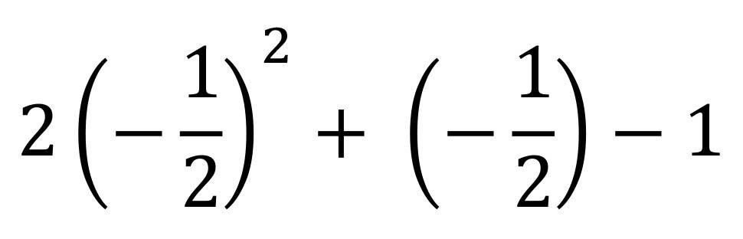

.
A.
-1
B.
0
C.
1
D.
2

38.

Given that x = 8, what type of angle is (9x + 8)º?
A.
Straight angle
B.
Obtuse angle
C.
Acute angle
D.
Right angle

39.

Express 0.725 as a fraction in its lowest term.
A.
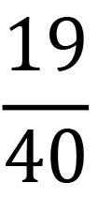
B.
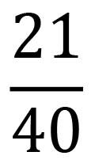
C.
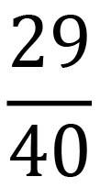
D.
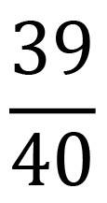

40.

Simplify 3(5a² + 2c) - 2a(1 - 3a) - 6c.
A.
21a² - 2a - 6c
B.
13a² - 2a - 12c
C.
13a² - 2a
D.
21a² - 2a

